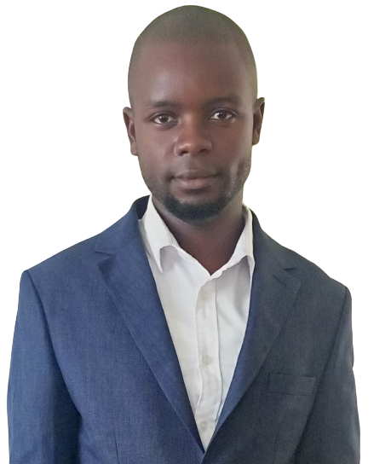

**Hobbies & Interests:**

**TUTORIAL FELLOW | Jaramogi Oginga Odinga University of Science & Technology** |2023 – To Date.

* Preparing, conducting tutorials, assessment and administration duties.
* Contributing to Department’s academic goals, where appropriate
* Undertaking coordination duties within the Department,
* Participating in quality assurance activities
* Contributing to external academic and professional activities,
* Provide within-course assessment and feedback to students on progress. Assessments may be; in class, out of class, or in a practical/professional setting.
* Assist in marking and assessment reporting in accordance with University guidelines

**TVET COORDINATOR ||: Jaramogi Oginga Odinga University of Science and Technology |** 2022 – To Date.

* Design a detailed methodological approach prior to commencement of assignment
* Mapping and recruitment of employers into the program for provision of internship opportunities
* Develop tools for implementation of the project e.g. recruitment and selection guidelines, mentorship guidelines, etc. in liaison with the technical training institutes.
* Coordinate implementation of soft Skills training to the TVET graduates
* Coordinating of Work Readiness works hops
* Identify industry mentors and support them to work closely with the TVET graduates for work place mentorship
* Placement of TVET graduates in participating industries.

**JUNIOUR RESEARCH FELLOW** **|: Jaramogi Oginga Odinga University of Science and Technology |** Dec. 2019 – Dec. 2022.

* Providing day-to-day advice, support, mentoring, and assistance to research graduates, students and other junior members.
* Identifying opportunities for external funding sources, prepare grant proposals and the assess research findings for potential commercial exploitation in collaboration with the PI.
* Preparing, conducting tutorials and assessments to Diploma Students.
* Carrying out any other duties as assigned by the Head of Department

**Jaramogi Oginga Odinga University of Science and Technology**

2023 – Present || **PhD. Applied Statistics**

**Maseno University**

2019 – 2022 ||**MSc. Actuarial Science**

**Jaramogi Oginga Odinga University of Science and Technology**

2015 – 2018 || **Bachelor of Actuarial Science |**First Class Honor and a Valedictorian of 6th Graduation in 2018

**Mwongori High School**

2010 – 2013 || **KCSE Certificate**|A- of 76 points

**Eronge Primary School**

2002 – 2009 ||**KCPE Certificate**|362mks



**Basic Digital Skills Training**

**• Nov. – Dec. 2017 || Certificate**

**• Travelling**

**• Hiking**

**Education:**

**Walter Nyanumba Motanya**

**P.O Box 2870-20108, NAKURU**

**Phone: 0790047918.**

**Email:** [**wnyanumba98@gmail.com**](mailto:wnyanumba98@gmail.com)

**Career History:**

**Profile Summary:**

I am a Tutorial Fellow with great passion in Research, Investment, Finance, Insurance and Statistical Modeling. I hold a Master’s Degree in Actuarial Science. My Experience in Predictive data modeling, Data Processing and Data Mining as well as Education qualifications set me apart as the ideal candidate for managerial roles, knowledge transfer and supervision roles with a great enthusiasm in Research, Data Science and Analysis. I am a dedicated team player who is highly motivated and articulate in communicating ideas to others and with proven success in leadership and group organization. I am adaptable and responsible individual with high level of integrity who upholds professionalism. I am self-driven with convicted spirit for the need for sustainable development, I dedicate my work to that fulfilment.

**Language Skills:**

* English (Proficient User)
* Swahili (Proficient User)

**Data Analysis Skills:**

* Statistical packages such as R, SPSS, and STATA
* Excellent skills in SQL, MATLAB, Python

**Digital Skills:**

* Micro Office i.e., MS. Word, MS. Excel, MS. Access, Publication
* Programming languages and Quantitative analysis software i.e., JAVA, C+, C

**Soft Skills:**

* Strong analytical and mathematical skills
* Strong writing and Communication skills Leadership and conflict Resolution skill
* Problem solving and Decision-making skills
* Time Management skills
* Ability to Work Under Pressure



* Modeling Statistical Data Analysis
* Market and Survey Research
* Financial mathematics
* Life and General Insurance
* Risk Mathematics
* Investment Mathematics

**CORPORATE PERFORMANCE ANALYST | Geothermal Development Company (GDC)** | Jan. 2019 – Jun. 2019.

* Conducting research or data gathering and Analyzing data
* Segregation, classification and analysis of data.
* Compilation of reports based on analysis, keeping in mind the end user's requirements.
* Presentation of findings in the form of graphs, tables, charts multimedia presentations.
* Using statistical tools to identify, analyze, and interpret patterns and trends in complex data sets that could be helpful for the diagnosis and prediction.

**INTERN | Kericho County Government) |DEPARTMENT OF FINANCE & ECONOMIC PLANNING**| May to October 2017:

Attached at County Government of Kericho in the department of Finance and Economic Planning from and carried out the following duties:

* Analyzing and preparation of various reports.
* Revenue data entry and analysis.
* Reviewing and analyzing the county budget and making projections for 2017-2018.
* Inspection and Collection of data from businesses for the automation of Single Business Permits (SBP).
* Interpretation and harmonization of different views from the public on various draft county documents.
* Preparation of county monitoring, evaluation framework and progress reports.
* Reviewing and evaluating performance of County Integrated Development Plan (C.I.D.P) 2013-2017 in preparation for development of second CIDP 2018-2023.
* Strong mathematical skills to help collect, measure, organize and analyze data
* Technical proficiency regarding database design development, data models, techniques for data mining, and segmentation.
* Knowledge of Programming languages like SQL, R, MATLAB, and Python.
* Experience in handling reporting packages like Business Objects, programming (Javascript or ETL frameworks), databases
* Proficiency in statistics and statistical packages like Excel, SPSS, & SAS.
* Adept at using data processing platforms like Hadoop and Apache Spark.
* Knowledge of data visualization software Training and Facilitation Skills

**Referees:**

**Technical Skills & Competencies:**

**Career History (Contd…)**

**Education & Qualification**

**Education & Qualification**

**OTHER KEY SKILLS IN DATA ANALYSIS:**

**Dr. Nyakinda Joseph ||** Head of Department

School of Biological, Physical, Mathematics and Actuarial Sciences

Jaramogi Oginga Odinga University Of

Science and Technology

**Mobile: +254 722 290 722**

**Email:** [**jnyakindas@yahoo.com**](mailto:jnyakindas@yahoo.com)

**Mr. David K. Ruto ||** Chief Economist

County Government of Kericho

**Mobile: +254 722 204 197**

Email: [**dkruto2001@yahoo.com**](mailto:dkruto2001@yahoo.com)

**Prof. Omolo Ongati ||** Head of Department

School of Mathematics and Actuarial Sciences

Jaramogi Oginga Odinga University Of

Science and Technology

**Mobile: +254 723 340 602**

**Email:** [**omoloongati@gmail.com**](mailto:omoloongati@gmail.com)

**Referees:**